# Report for Benji Sheesley (2024-10-01 to 2024-10-31)

Average Bat Speed: 48.95

Average Rotational Acceleration: 8.61

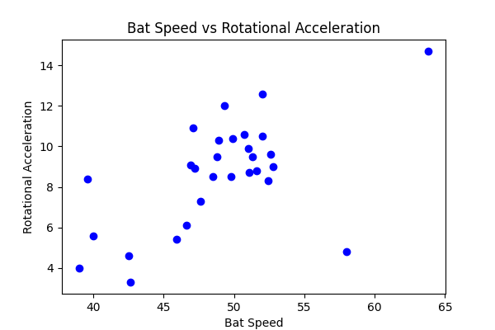

## Comments

Add comments here...